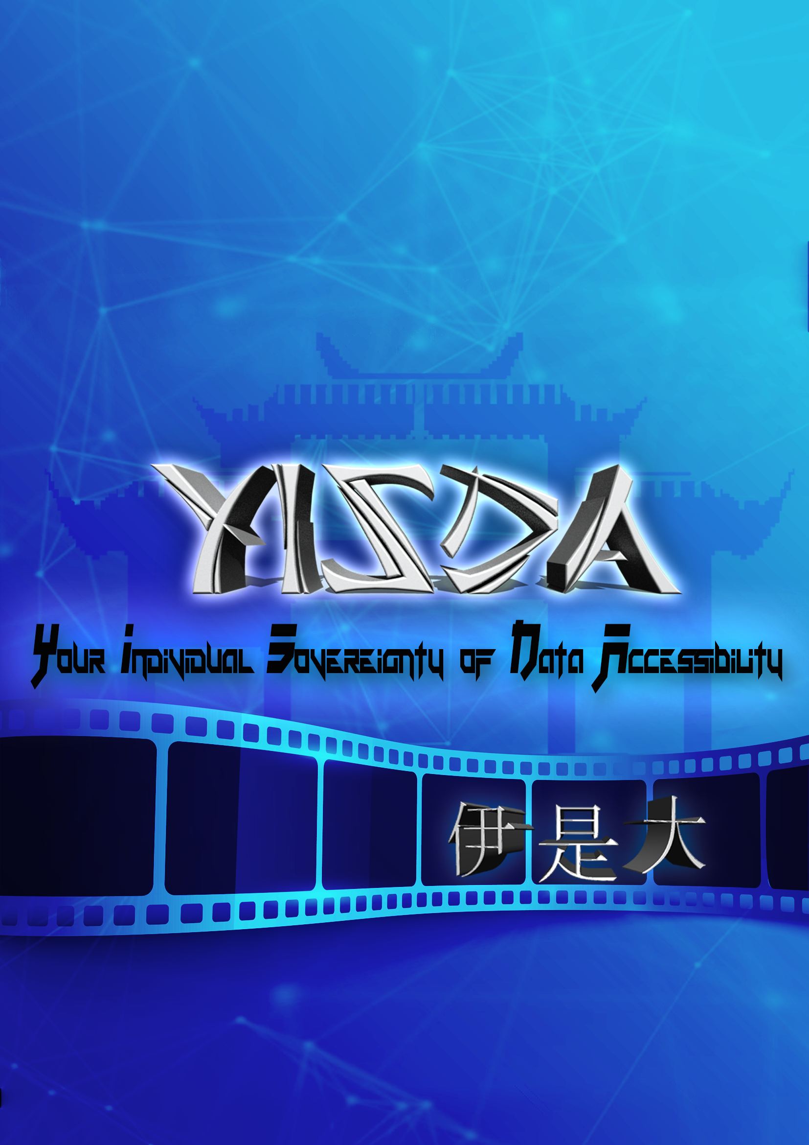

WHITE PAPER

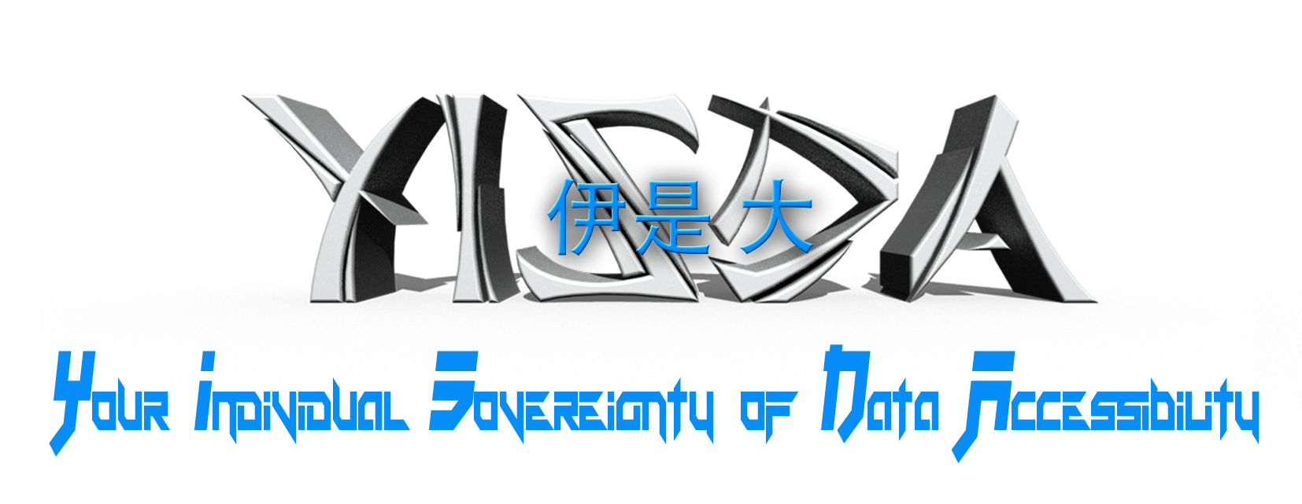

**Decentralized Multimedia Streaming Platform**

(formerly known as SAFEtube)

Ryan Richardson

William Gallo

RJ Tolson

**Abstract**

YISDA is a decentralized multimedia platform for entertainers and content producers of all types to share and promote their content in the first massively-available, uncensored streaming service, made possible by the p2p architecture complimented by MaidSafe’s SAFE Network. Promotion of content is handled in a completely decentralized manner through the utilization of the blockchain-based Tubecoin token, which is burned directly back into the platform when content producers wish to boost their content to the global audience. Users data & media is stored on no centralized server, but sharded in encrypted SAFE Network nodes on users hard drives around the globe, eliminating downtime with multiple archived replications, and secured further through Data Chain live backup technology. YISDA aims to be the first massively-adopted, uncensorable, node-based application running on MaidSafe’s SAFE Network, to push this specific platform and overall decentralization movement forward.

**Contents**

Abstract 02

Introduction 04

YISDA Paradigm Shifts 05

Decentralized Architecture 06

MaidSafe as a Platform

Decentralized Internet

Uncensorable Information

Cross-Platform Security & Accessibility

Decentralized Development 07

Initial Core Developers

Core Development Partners

Open Source Community Integration

Decentralized Code Bounties

Tubecoin Utility 07

Promotion of Content

Kickstarting Projects

AFE Network Token Sales

ICO Token Sale 08

Releases & Launches 09

Video Audio Image Text Social

History & Roadmap 10

Official Partnerships

Entertainers

Marketers

Developer

SAFE-FS Foundation 12

APPENDIX 12

SOURCES 13

**Introduction**

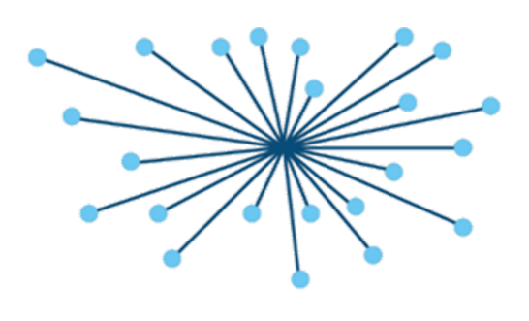In the current global paradigm contemporary systems of government, incorporation and power, centralization reign to supreme. While it is easier to simply give all power and control to a central group and hope for the best, it is not the most sustainable and safe model for society in the long run. Private companies and governments are perfect examples of groups that have proven themselves to pose threats to the equality within society, as there have been many unceasing examples of ways these entities misuse their power for internal gain. Not meant as a personal attack, but instead as a deeper analysis of the systematic flow of these groups, these statements urge the masses to find solutions by examining the underlying structures being used.

[1], Vimeo ,YouTube, and others are excellent case studies of centralized power and control over a market. Both began as privately-held companies which have been bought out and had their internal leadership changed[2]. This has resulted in the loss of contribution and influence from the original designers of the applications, and potential degradation of the original vision. While new control can lead to new opportunity, the issues of systematic control began for each company on the first day of their centralized organization, and only shifted to new centralized entities at each step of the way. Both platforms have many backlogs of “suggestions” and negative feedback from their millions or billions of users, which can not be addressed at all unless the central owners confirm each feature. The central architecture is in no way openly extensible by the users, which affects society as a whole.

Video streaming current

**YISDA Paradigm Shifts**

Allowing complete access of multimedia content online to all the world’s people could have massively disruptive effects on the current digital economy and industry players within the current global market paradigm. Built on the iron principles of privacy, security and freedom that underly MaidSafe’s SAFE Network, YISDA offers a complete multimedia sharing framework and social platform for the publishing and promoting of digital content.

With advertising and promotion being handled autonomously by the digital YISDA Coin asset, no outside entities or agreements are necessary for content creators to market or profit from their creations. This presents the first and most major iteration of an idea-sharing marketplace with no middlemen, only content producers and content consumers directly working together, sharing their creations, and supporting each other’s new artistic work.

This is in a stark contrast to the economic model of today’s digital economy, where the platforms are owned by large corporations that hold all the data and profits for themselves. Furthermore, systems today involve payment systems that withhold the digital files from customers until they are paid for, which is a dated model that sees limited success as technology progresses. It becomes more and more difficult to create an impenetrable paywall between customers and digital files, as the internet is inherently designed to share, copy, and distribute data between users. Instead of resisting this tendency, YISDA thrives within it. It allows artists to unleash their creations to the world, with the faith that their valuable work will be supported by the much wider audience they are now reaching, now that there are no walls that potential customers have to climb to view what the artists have made.

YISDA transforms nearly every online economic model, and helps spawn a sustainable, decentralized movement, showing people to how to empower themselves through art, entertainment, and code.

ly constitutes the vast majority of bandwidth consumption on the internet, and this sector is on track to only become more dominant over time. The Cisco Visual Networking Index writes that by 2019, 80% of internet traffic will be due to video content[5], and that this trend could expand global IP traffic to 3.3 Zetabytes by 2021[4]. Furthermore, new types of video consumption are on track to quintuple the amount of online internet traffic within five years[3]. With the most viewers and users, this sector is one of the fastest-growing online industries, but also has many weaknesses that need to be redesigned by use of new and cutting-edge system architectures.

**Decentralized System Architecture**

Now is a time of unprecedented expansion and support for decentralized systems, currencies, and organizations, and YISDA is taking that in a new direction. As a completely decentralized multimedia viewing and promotion platform, it provides the first physically secured, infinitely scalable, and fully decentralized architecture for this mass-market consumption of data that the world has ever seen. This is made possible by the decentralized architecture and development of the platform, which are explained further in the sections below.

MaidSafe as a Platform

MaidSafe.net Ltd. is a Scottish Non-Profit Charity entity that was responsible for one of the very first major ICOs in history, and pioneered the entire space in the earliest days of crypto. Furthermore, it has been working to decentralize the internet with encryption and a cryptocurrency token called SafeCoin more than 5 years before Bitcoin (the first massively-adopted blockchain currency) ever existed. As true trailblazers and the most forward-thinking group in the entire space, the MaidSafe team is in the later stages of testing and release of their decentralized internet protocol, which has had over 20 public test networks and two Alpha Network releases to date.

As this is cutting-edge technology, personal relationships with the YISDA group have been formed with the MaidSafe team to facilitate interoperability between the projects. As the only officially recognized partners of MaidSafe.net Ltd, “MaidSafe Asia” is assisting with the marketing of YISDA, to help take it to the mass audience as quickly as possible, in its efforts to push the MaidSafe SAFE Network forward into the public eye. Additionally, Will “WhiteOutMashups” Gallo is playing a heavy role in advising the initial technical aspects of YISDA’s development, as he has been involved in the MaidSafe community since the earliest days of its public release, and has developed close relationships with many of the MaidSafe team members both in their headquarters in Troon and in San Francisco California. He has over 4 years developing applications that successfully interface with MaidSafe’s SAFE Network, and helps ensure that initial versions run smoothly for all users, and are well documented for open-source developers to improve upon them.

Decentralized Internet

A Decentralized Internet is a global network that operates with much higher degrees of efficiency and security than current server-based solutions. This powers applications that

Uncensorable Information

Cross-Platform Security & Accessibility

**Decentralized Development**

As an open-source and decentralized platform, development of YISDA takes place in a distributed and ownerless fashion from the very beginning. While initially being boosted by the expertise of the core YISDA technical team, the the global open-source development community is empowered to take a major role in extending and expanding the codebase in additional directions. This approach allows for YISDA to gain an increasing and sustainable share of the online video & media streaming markets, by offering new features and user-guided upgrades at a much faster rate than current competitors, as well as a wide array of additional benefits.

Initial Core Developers

Core Development Partners

Open Source Community Integration

Decentralized Code Bounties

**Tubecoin Utility**

YISDA Coin (YSDA) is the first massively-marketed “altcoin” token built on the SAFE Network. Like the underlying Safecoin of the SAFE Network, Tubecoin exists as a blockchain-based proxy token until network launch. This token can be purchased immediately at the launch of the YISDA ICO with bonuses depending on the round participated in, and amount purchased. Additionally it can be purchased afterwards on exchanges, but will be subject to market rate at that time.

The coin has a variety of use cases, with the central function being to promote decentralized content on the YISDA multimedia platform. This and other use cases are described below.

Promotion of Content (with graph showing coins going back into the system)

SAFE Network Token Sales (shows ppl buying TUBE to purchase new promoted altcoins)

Decentralized Kickstarting (figure showing people sending coins to their fav projects)

Microdonations (figure showing people supporting their favorite people)

As the YISDA platform has an internal social network framework, it offers a next-generation way for consumers to interact with producers, far beyond simply adding a “like” or “smiley face” to their posts. YISDA is built on the SAFE Network as a SafeCoin altcoin, which makes it the only technology that can cheaply and efficiently process micropayments. Blockchain currencies such as Bitcoin, Ethereum and others have proven massively inefficient for this use-case, as all transactions have to be recorded in perpetuity on the blockchain, which then requires them to be backed up across all nodes and increase in size, slowing down the entire network over time. For these reasons and more, blockchain-based currencies are not suitable for micropayments, however YISDA Coins are.

This allows YISDA Coins to be used by fans to send a microdonation to their artist with the click of a button, as easily as it is for a user to click “Like” on Facebook, or “Subscribe” on YouTube. YISDA offers the option to preset this donation to a specific amount, and have different levels of donations, such as a “Smiley face” representing a slightly larger donation, and a “heart” symbolizing an even larger payment. Subscription systems—or reoccurring donations over selected intervals of time—are offered by the initial versions of YISDA as well, for fans to support the creators of their choice for the long term. Since the SAFE Network allows open access to all data, it becomes difficult in this new digital economy to force users to pay for any digital content. Therefore, the forward-thinking YISDA economic approach involves content producers of any type to instead focus on building up their fanbase, which voluntarily supports them with donations of all sizes. This is a sustainable and purely peer-to-peer model for the data economy of the future.

**Token Sale**

The YISDA ICO Token Sale exists in specific jurisdictions, in order to provide funding for the initial developers to properly release, document, and market versions 1.0 through 5.0 to the world. This ensures the successful launch of all parts of the platform, and allows ample resource for it to reach a point where the platform is approachable enough for open-source developers and general users can take YISDA in any direction they need to.

The ICO consists of two rounds and several sub-rounds, which all have different bonuses depending on the amount invested. These phases are explained below:

Angel Round (hard cap $10,000,000)

This round is advertised primarily to larger investment groups throughout the ASEAN countries, as well as angel groups interested in promising cryptocurrency projects. This primary round exists to secure the initial funding needed for the

Platinum Angel $50,000 Invested 50% bonus 2500000 TUBE per ETH

Gold Angel $25,000 Invested 25% bonus 250000 TUBE per ETH

Silver Angel $10,000 Invested 10% bonus 50000 TUBE per ETH

Angel Bonus Packs: shows the metal / gold etc Tubecoins with private key code, as well as shirts, hats, stickers and other merchandise free of charge. Similar items get sold on our website to others.

Main ICO Round

This is the main round of the ICO and has several sub-rounds, depending on the amount invested:

$5,000 minimum – Series A 5% bonus 25000 TUBE per ETH

$1,000 minimum – Series B 1% bonus 5500 TUBE per ETH

$100 minimum – Series C 0.1% bonus 5050 TUBE per ETH

$10 minimum – Series E Investor. No bonus. 5000 TUBE per ETH

**Releases & Launches**

The YISDA multimedia platform will be released in several stages, each with customized outreach and marketing campaigns to complement them, and boost adoption for each user base.

Video Publishing (v1.0) – Jakarta

As the flagship application of YISDA, video publishing will constitute version 1.0 of the platform release, and this initial version will have its entire UI focused around this particular use-case. LINK TO THE PART OF THE ROADMAP THAT TALKS ABOUT THE RELEASE EVENT HERE.

Audio Publishing (v2.0) – KL

Image Publishing (v3.0) – India

Text-Based Publishing (v4.0) – Japan

Social Network (v5.0) –

**History & Roadmap**

August 12th, 2014 – [Decentralized Video Platform proposed by MaidSafe community](https://safenetforum.org/t/most-wanted-app-for-the-safe-network/1112) as one of the Highest Rated Desirable Applications to showcase the p2p network technology.

October 1st, 2014 – In the earliest days of SAFE, WhiteOutMashups designs and [publishes an initial web version](http://wkgallo3.github.io/Appsitev2) describing the vision and potential branding of a [SAFE Network Drive application](http://wkgallo3.github.io/Appsitev2/SAFEdrive.html) that could expand to host and display all filetypes & multimedia content on this p2p network.

2014 – 2016 – Will “WhiteOutMashups” works in San Francisco California at the very first MaidSafe International Pod alongside Daniel Dabek and MaidSafe employee Paige Peterson to kickstart decentralized development of the platform and applications, complimentary to the MaidSafe Headquarters in Troon Scotland. Working closely with Daniel Dabek, CEO & Founder of the SafeExchange decentralized exchange project, Will develops various frameworks and early tools for the SAFE Network, including a decentralized “SafeAppStore” marketplace framework.

June 26th, 2016 – From the above ideas and support, WhiteOutMashups develops and releases the SAFE Network FileSystem “SAFE-FS” to provide a foundational framework for storage and search of public data through utilization of the SAFE Network protocol.

2016 – 2017 – MaidSafe releases TEST Networks 12 – 19 as well as Alpha 1 & Alpha 2 Networks, and refines its developer-facing APIs in several programming languages. Meanwhile, SAFE-FS expands its team, protocols, and customized API wrappers to further solidify foundations for third-party applications to interface with and store data on the SAFE Network.

January 10th, 2017 – Using the frameworks and team from his SAFE-FS & SafeAppStore projects, WhiteOutMashups solo-develops an initial version of a SAFE Network Multimedia Platform entitled “SAFEtube,” with a completed live version running successfully on the early TEST 11 version of the MaidSafe Network.

Q3 2017 – SAFE-FS partners with MaidSafe Asia, which is the only officially endorsed partner of the main MaidSafe UK company of Troon, Scotland. This partnership allows a much wider access to funds, events, marketing and expansion of the MaidSafe vision, as well as its open-source applications.

2018 - 2019 – An Asia Road Tour is planned (*[See “Releases & Launches” section above](http://aslkjdlksajd/)), to showcase the open development of the uncensorable YISDA multimedia platform across several countries, with the core team. This is further fueled by a well-funded, aggressive, and multi-language marketing plan on all major social networks and further announced to many major cryptocurrency discussion groups, where open conversations with all core team members are possible in perpetuity.

H2 2018 – In-person meetings with dozens of licensed cryptocurrency exchanges in various countries are being scheduled, allowing for Tubecoin to be listed and airdropped in accordance with their terms and conditions. This will allow Tubecoin to be easily purchased by a wide range of investors, through multiple cryptocurrency—and possibly fiat—trading pairs.

2019 – YISDA continues its programs for expanding adoption of its multimedia platform through Reserve Airdrops to current content producers on YouTube, Vimeo and other multimedia platforms, which allows those producers to market themselves on YISDA free of charge. Programs such as this increase the adoption of the platform and userbase for the token, allowing benefits for all involved, and enhancing privacy and open access to information around the globe. In tandem, development of the platform extends as the core network is refined and adapted around future hardware for nodes, to secure the decentralized routing of data.

2020 & Beyond – The platform continues its decentralized global expansion with its original development group as well as through all parties involved in the platform, who all have financial incentives to expand adoption of the YISDA platform as well as marketing their own boosted content to the world. During this time uncensored access to data rapidly changes the global information economy, and YISDA works to secure its place as the main multimedia streaming service of this new paradigm.

**Official Partnerships**

Entertainers

Marketers

Developers

SAFE-FS

**SAFE-FS Foundation**

**APPENDIX**

Node

Producer / Artist / Creator – Terms used interchangeably to describe any party who uploads (video, audio, text, image) work to the YISDA platform for distribution to the global audience.

SAFE Network

MaidSafe

MaidSafe Asia

MaidSafe UK / Troon

SAFE-FS

WhiteOutMashups

Routing

Data Chain

YISDA

SAFEtube

Cryptocurrency

Tubecoin

Fiat

SafeAppStore

TEST 11

Alpha 1 & 2

FileSystem

SafeExchange

P2P

Shard

Decentralized

API

Reserve

SOURCES

[1] TIME – Brief History of YouTube – <http://content.time.com/time/magazine/article/0,9171,1990787,00.html>

[2] BuiltInNYC – Brief History of Vimeo – <https://www.builtinnyc.com/2016/05/02/brief-history-vimeo>

[3] Recode – Online Video Could Triple Bandwidth within 5 Years – <https://www.recode.net/2017/6/8/15757594/future-internet-traffic-watch-live-video-facebook-google-netflix>

[4] Cisco Visual Networking Index – <https://www.cisco.com/c/en/us/solutions/collateral/service-provider/visual-networking-index-vni/complete-white-paper-c11-481360.html>

[5] TubularInsights – By 2019, 80% of the World’s Internet Traffic will be Video – <http://tubularinsights.com/2019-internet-video-traffic/>

[6] – [29] Sources...